Research Report
Accelerometer and Gyroscope
I. Accelerometer (ADXL345) on breakout board

a. FEATURES
■ Ultralow power: as low as 23 μA in measurement mode and 0.1 μA in standby mode at VS = 2.5 V (typical)
■ Power consumption scales automatically with bandwidth
■ User-selectable resolution
+ Fixed 10-bit resolution
+ Full resolution, where resolution increases with g range, up to 13-bit resolution at ±16 g (maintaining 4 mg/LSB scale factor in all g ranges)
■ Patent pending, embedded memory management system with FIFO technology minimizes host processor load
■ Single tap/double tap detection
■ Activity/inactivity monitoring
■ Free-fall detection
■ Supply voltage range: 2.0 V to 3.6 V
■ I/O voltage range: 1.7 V to VS
■ SPI (3- and 4-wire) and I2C digital interfaces
■ Flexible interrupt modes mappable to either interrupt pin
■ Measurement ranges selectable via serial command
■ Bandwidth selectable via serial command
■ Wide temperature range (−40°C to +85°C)
■ 10,000 g shock survival
■ Pb free/RoHS compliant
■ Small and thin: 3 mm × 5 mm × 1 mm LGA package
■ 3-Axis, selectable sensitivity: ±2 g/±4 g/±8 g/±16 g Digital Accelerometer
b. Why it is suitable for FUFO project?
- 3-Axis Digital Accelerometer
- flexibly selectable sensitivity: ±2 g/±4 g/±8 g/±16 g
- High shock survival: 10000g
- Supply voltage range: 2.0 V to 3.6 V
- I/O voltage range: 1.7 V to 2.5 V
- SPI (3- and 4-wire) and I2C digital interfaces
II. Gyroscope (L3G4200) on breakout board
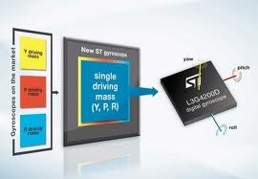
a. Features
■ Three selectable full scales (250/500/2000
dps)
■ I
2C/SPI digital output interface
■ 16 bit-rate value data output
■ 8-bit temperature data output
■ Two digital output lines (interrupt and data
ready)
■ Integrated low- and high-pass filters with user-
selectable bandwidth
■ Ultra-stable over temperature and time
■ Wide supply voltage: 2.4 V to 3.6 V
■ Low voltage-compatible IOs (1.8 V)
■ Embedded power-down and sleep mode
■ Embedded temperature sensor
■ Embedded FIFO
■ High shock survivability
■ Extended operating temperature range (-40 °C
to +85 °C)
■ ECOPACK® RoHS and “Green” compliant
b. Why it is suitable for FUFO project?
- ultra-stable three-axis digital output gyroscope
- I2C/SPI digital output interface
- 16 bit-rate value data output
- 8-bit temperature data output
- Wide supply voltage: 2.4 V to 3.6 V
- Three selectable full scales (250/500/2000 dps) is capable of measuring rates with a user-selectable bandwidth.
III. Breakout Board
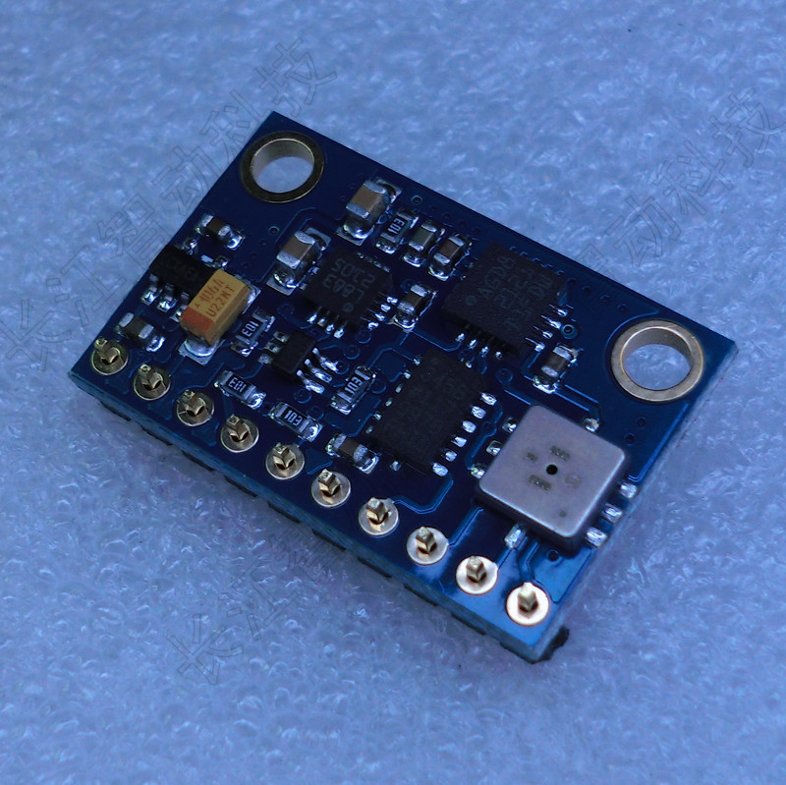
a. Description
- It includes:
+ L3G4200: gyroscope
+ ADXL345: accelerometer
+ BMP085: pressure sensor
+ HMC5883L: digital compass
- Price 1.1 million vnd
- Link: http://hocarm.com/ISC2/products.php?product=9DOF-%3A-BMP085-%252b-L3G4200-%252b-ADXL345-%252b-HMC5883L

